* KNN , Naïve Bayes, SVM algorithms are used for calculating the accuracy of our model.
* This table depicts the accuracy of each algorithm.

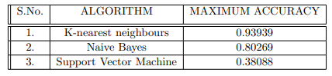

* On comparing the three algorithms , K-nearset neighbour algorithm gives best performance with highest accuracy.